North Lake Senior Campus: ATAR Chemistry Year 11

**Discovering the Atoms Structure : Name : _____________________**

1. Describe 2 theories of Dalton’s that are still valid today [4 marks]
2. *Atoms of different elements vary in size and mass*
3. *Elements have to be combined in fixed proportions or ratios*
4. a) What equipment did Thomson use for his experiments? [ 1mark]

*Cathode Ray Tube*

b) Describe two of the experiments Thomson carried out using this equipment and his observations. [ 4 marks]

*Any 2 of the following, 2 marks each.*

1. *Allowed the cathode rays to travel through air. The distance they travelled was further than he thought which suggested the particles were smaller than an atom.*
2. *He passes the rays through electric and magnetic fields in a vacuum.*

*He was able to measure the angle at which they were deflected and calculate the ratio of the electrical charge to the mass of the particles. He discovered that the ratio was the same regardless of what type of gas was used, which led him to conclude that the particles that made up the gases were universal.*

*(iii) He used a cloud chamber to establish that a cathode ray particle carries the same amount of charge as a hydrogen ion*

c) What conclusions did he draw? [ 3 marks]

* *Cathode ray particles were negatively charged.*
* *Cathode ray particles were at least 1000 times lighter than a hydrogen atom.*
* *Whatever source was used to generate them, all cathode ray particles were of identical mass and identical charge*

*They were fundamental particles.*

d) What model of the atom did he propose? [1 mark] Include a diagram [2 marks]

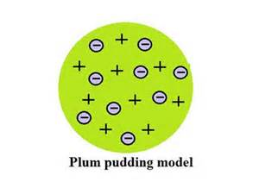

*Evenly distributed positive and negative charges, so the atom is held together by electrostatic forces*

1. a) Describe the experiment that Rutherford performed (include a diagram)

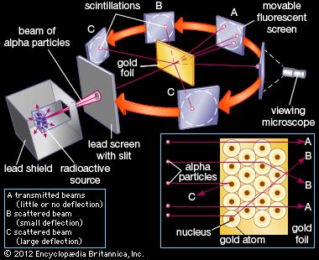 [2 marks]

*Rutherford fired a narrow beam of alpha particles at a thin section of gold foil*

*It was surrounded by a scinitillating Zinc Sulfide screen, so that when the alpha particle hit the screen it would produce a burst of light. [ 2 marks]*

b) What did he observe? [ 2marks]

*Most alpha particles were observed to pass straight through the gold foil, which implied that atoms are composed of large amounts of open space.*

*Some alpha particles were deflected slightly, suggesting interactions with other positively charged particles within the atom.*

*Still other alpha particles were scattered at large angles, while a very few even bounced back toward the source.*

c) What conclusions did he draw and what model did he come up with ? [ 4marks]

*That an atom contains a heavy central positively charged nucleus, to account for the strong repulsion [ 1 mark]*

*The negative electrons that balanced electrically the positive nuclear charge were regarded as traveling in circular orbits about the nucleus. The electrostatic force of attraction between electrons and nucleus was likened to the gravitational force of attraction between the revolving planets and the Sun. Most of this planetary atom was open space and offered no resistance to the passage of the alpha particles.*

[ 3marks – diagram not essential if explanation clear]

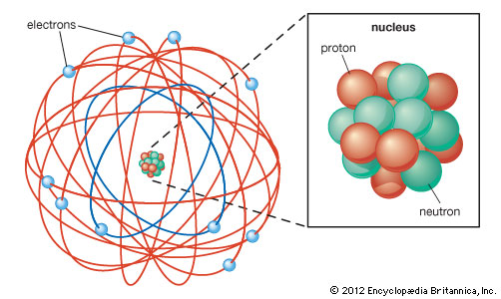

1. a) In what way was Bohr’s model similar to Rutherford’s. [1 mark]

*Negatively charged electrons orbit a small positively charged nucleus*

b) How did Bohr modify the understanding gained by Rutherford? Include a diagram. *(something like)* [ 2 marks diagram, 3 marks explanation]

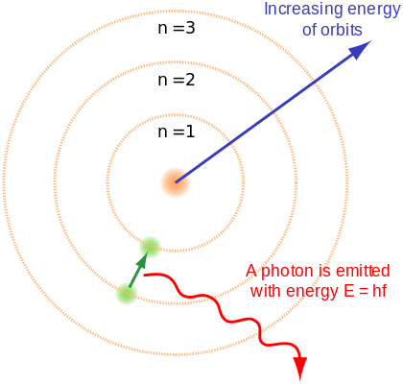 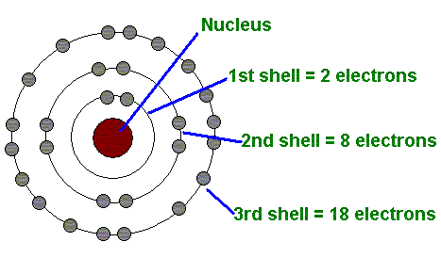

*Electrons travel in discrete or fixed orbits around the nucleus,*

*That an electron could absorb or emit energy in only discrete amounts (the exact amount as the difference between the two energy levels)*

*If an electron goes to a lower level it emits light and if it goes to a higher level it absorbs light.*

1. a) What particle did Chadwick discover? [ 1 mark]

*Neutron*

b) What experiments did he use ? [ 2 marks]

Expts where unidentified radiation from Be hit paraffin wax and knocked loose protons from hydrogen atoms, which recoiled with high velocity (Originally performed by the Joliot-Curie’s and repeated by Chadwick with other targets)

c) What did he find out about the mass and the charge? [ 2 marks]

*That it was neutral charge and about the mass of the proton*

END OF TEST